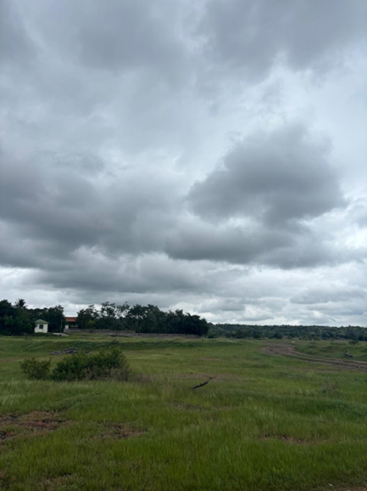

Socio-Economic Determinants of Packaged Food Consumption and Living Conditions in rural Sangamner:
Insights from a Fieldwork Immersion

Submitted By: Krisha Mitra
Enrolment Number: M2024BSASS015

Contents
Introduction 2
Methodology 2
Analysis 3
Summary 6
Conclusion 6
References 8

Introduction
This report is based on a rural immersion program in Sangamner from the 3rd to the 13th of September, part of the Semester 2 curriculum BSASS at TISS Mumbai. This was our first significant experience living and interacting in a rural community as first-year undergraduate students. The objective of the programme is to develop a deep understanding of village society, including local economies, social structure, agriculture, access to resources, health, education, and government welfare schemes. The immersion helped us see and understand the everyday life of people living in villages, often very different from urban life. It revealed both the resilience of rural households in managing limited resources and the cultural fabric that makes rural life distinct from city dwelling.
During the immersion, we visited many households and talked to the villagers. We learned about their lifestyles, the things they use daily, and the challenges they face. We focused on understanding people's food habits, cooking energy sources, types of ration cards they have, education levels, and household sizes. We also collected information on how much packaged food they eat. These factors are important because they show rural areas' quality of life and economic conditions.
Rural areas often have less access to clean energy, education, and food than cities. Many people use traditional energy sources, like firewood, for cooking and may have limited access to packaged or processed foods. The ration card system also significantly influences how households get food and other essentials. Education levels vary and affect their income and lifestyle choices. Household size can affect how resources are shared and consumed within a family.
Collecting this information directly from the community gave us valuable insights. It showed us the realities of rural living and made us appreciate rural families' daily struggles. It also helped us understand the importance of government schemes like the ration card system and how they impact food security.
This report analyses household data to explore factors influencing packaged food consumption using statistical methods like ANOVA and correlation. We aim to understand rural life better and identify areas needing support or intervention for improved rural development.

Methodology
The data for this report was collected during a rural immersion program conducted in Sangamner from 3rd to 13th September. The immersion involved visiting and interacting with 116 households, representing 691 household members. This sample size provided a fairly comprehensive view of the rural community in the area.
Data collection was done through structured household interviews. We focused on key socio-economic variables, including the type of ration card the household possesses, the primary energy source used for cooking, total packaged food quantity consumed, education levels of household members, and household size. The interviews were conducted with the heads of the households or adults responsible for food procurement decisions.
The data collected was entered into Excel for analysis. Numerical variables like packaged food quantity and household size were treated as continuous data. In contrast, others, such as ration card type and energy source, were treated as categorical data represented by codes given in the tool.
For statistical analysis, Analysis of Variance (ANOVA) was conducted to understand if there were significant differences in the mean packaged food quantity across different types of ration cards and energy sources for cooking. ANOVA is useful when comparing means across three or more groups.
Independent samples t-tests were done to compare means between two groups, such as education level groups or household size categories.
The sample size of 116 households was adequate for detecting meaningful statistical differences with sufficient power. All statistical tests were conducted using Excel's Data Analysis ToolPak. A significance level of 0.05 was used, meaning that p-values below 0.05 were deemed statistically significant.
The immersion experience allowed us to understand the socio-economic context and the observed data, making this a quantitative and qualitative analysis.

Analysis
Theme: Socio-Economic Factors Shaping Packaged Food Consumption and Household Living Patterns in Sangamner
This report explores how key household socio-economic factors influence packaged food consumption and living conditions in rural Sangamner.
The rural food environment is changing quickly due to urban growth, economic changes, and new policies. It’s important to understand how different factors influence people’s eating habits and how they use resources.
Packaged food consumption shows how rural households are shifting their diets, modernizing, and improving their economic situation. This study looks at how the amount of packaged food relates to factors like ration card type, education level, household size, and cooking energy source. It aims to uncover how access to resources and economic status affect food choices and lifestyles.

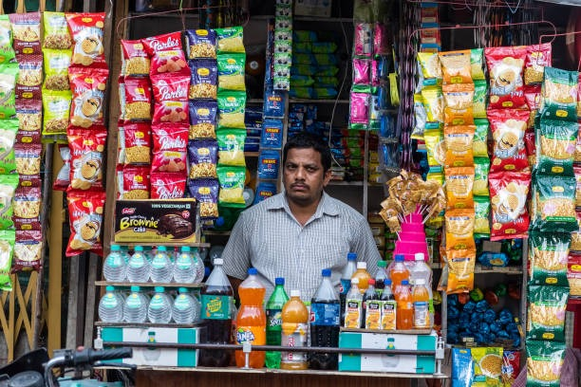
Our data was collected in an immersive fieldwork program involving 116 households with 691 members.
This sample size was adequate to create the case studies and reports.
Statistical tests were run to reveal significant group differences and associations, contributing to a nuanced understanding of rural lifestyles and resource disparities.
Five statistical tests were conducted: three ANOVA analyses investigating differences in packaged food consumption and energy sources across groups, and two t-tests comparing group means between categories.

1. Impact of Ration Card Type on Total Packaged Food Consumption
Objective: To analyse whether households' ration card type, a proxy for economic entitlement, is linked to differences in the quantity of packaged food consumed.

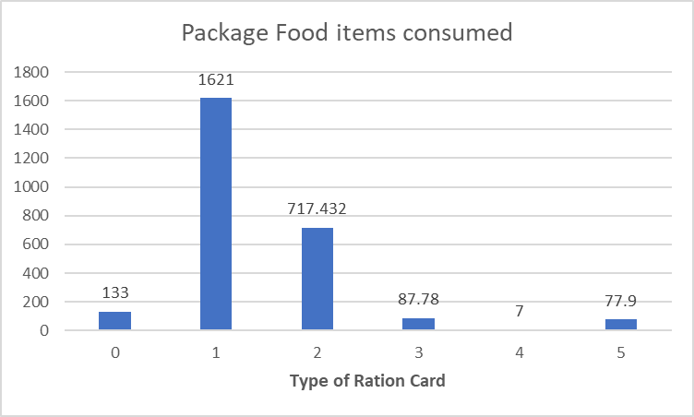

Lower income groups tend to relay on low quality package foods, especially the children consume the low-ticket snacks available easily around the area. While higher economic status, shows more inclination towards consumption of dairy, vegetables and fresh food consumption.

Test : ANOVA
Interpretation:
Results show a significant difference in packaged food quantity between ration card types (F=5.06, p=0.025). This shows that different types of ration cards affect households' ability to access or purchase nutritious food or eat empty calories packaged food. Likely, households with better cards have higher purchasing power, reflecting socio-economic tiers within the rural population, influencing diet patterns.
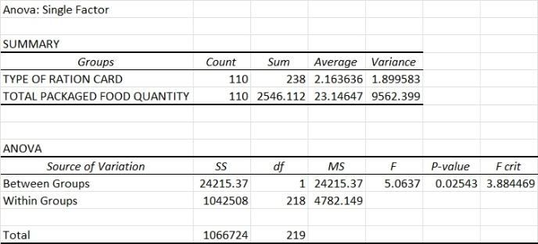

2. Influence of Highest Education Level on Packaged Food Consumption
Objective: To explore if educational attainment among household members correlates with changes in packaged food consumption levels.
Test : ANOVA
Interpretation:
This test showed a borderline p-value of 0.052. Higher education levels may be linked to slightly more packaged food consumption. Education could improve awareness and buying habits.
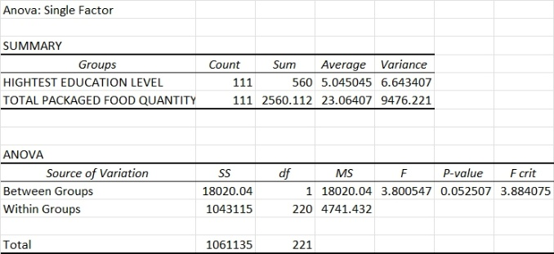
3. Association between Ration Card Type and Energy Source for Cooking
Objective: To evaluate how economic status (ration card type) relates to energy source choices in rural households.
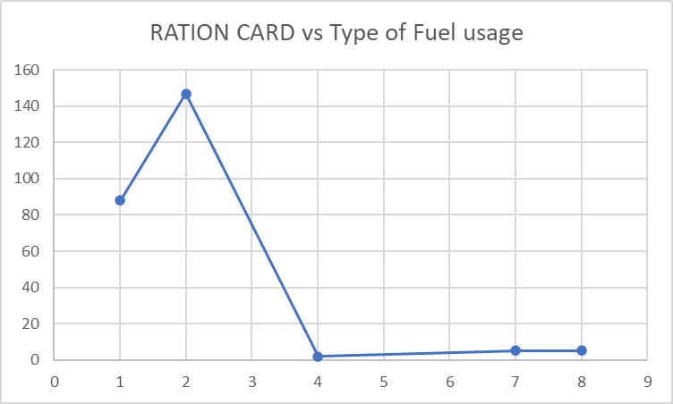

Test: ANOVA

Interpretation:
A statistically significant result was found (F=4.10, p=0.044). Families with better ration cards are more likely to use modern fuels such as LPG. In contrast, other families tend to rely on traditional biomass. This shows how socio-economic status affects access to basic amenities.
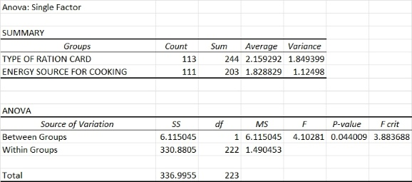
4. Differences in Packaged Food Consumption by Energy Source for Cooking
Objective: To compare the means of packaged food consumption between households using modern fuel sources and traditional fuels.
Test: t-Test

Interpretation:
A clear difference was found (t=2.37, p=0.019). Households with modern energy sources eat more packaged food, on average. This shows how modernisation and access to energy can change diets. Better energy access often goes hand in hand with economic growth and lifestyle changes.
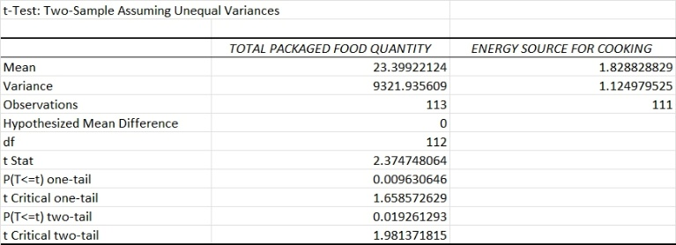
5. Household Size Differences by Energy Source for Cooking
Objective: To assess whether household size varies depending on the cooking energy source.
Test: t-Test

Interpretation:
This analysis found a significant difference (t=10.66, p<0.0001). Smaller households are more likely to use modern cooking fuels, while larger families often rely on traditional biomass or firewood, likely because of cost. This shows how household size and economic factors influence energy use and resource distribution.
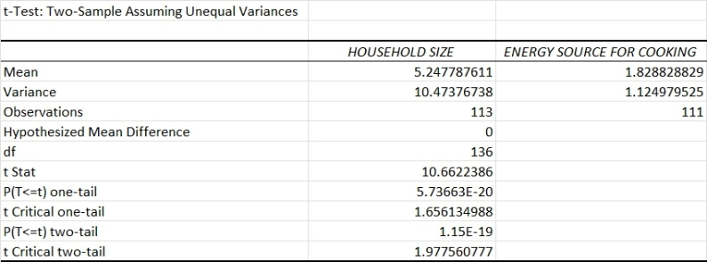

Summary
These results show that having a ration card, education, and good energy sources changes how people live in rural areas. Families can get packaged food and cleaner fuel based on how much money they have. This shows that living conditions are different in rural India. Knowing this can help make better food, energy, and health plans in places like Sangamner.
Discussion
This report shows important socio-economic factors that affect packaged food use and living conditions in rural Sangamner. The findings highlight how rural residents' access to resources and lifestyle choices depend on their economic status, education, family size, and available infrastructure.
The type of ration card significantly affects how much packaged food households consume. Households with better ration card categories tend to buy more quality packaged food. This aligns with the idea that ration cards affect access to subsidised goods, influencing overall dietary choices.
Education is important in our lives. It can help people earn more money, but it does not always mean they will eat better. Other things can affect what we eat. So, just learning more is not enough to change our diets. We also need to think about money and how it affects food choices.
How people get their ration cards shows their financial status and how it affects their access to energy sources. Richer families usually use cleaner fuels like gas, while poorer families rely on wood or other old methods. This can affect both health and the environment. Access to clean energy is a good sign that a community is developing well.
Studies show that households using modern fuels consume more packaged food. This suggests that dietary habits also change as energy use becomes more modern. People tend to eat more processed foods as their economic situation improves.
Additionally, households that use modern fuels tend to be smaller. This means that factors like family size and economic status affect resource use. Smaller households can afford modern fuels, while larger households may stick to traditional fuels to save money.
These findings help us understand changes in rural areas' food habits and living conditions. They highlight the need for policies that support economic growth, education, infrastructure, and nutrition to promote healthier and more sustainable development in rural India.

Conclusion
This report examined the lives of rural households in Sangamner by making direct observations and analysing data. It examined how social and economic factors relate to the consumption of packaged food, uncovering important patterns that affect food security and lifestyle in rural areas.
The study found that the type of ration card a household has influences their use of packaged food. Households with better ration cards tend to have more access to packaged foods, showing how a family's economic status affects their nutrition and food choices.
Education level showed a weak link to dietary habits. This suggests that knowledge slowly influences food choices. The use of energy sources is connected with household economic status. Cleaner fuels are related to higher packaged food consumption and smaller family sizes. This shows the relationship between economic growth, available resources, and lifestyle changes in rural areas.
The immersion experience helped us see more than just numbers. It revealed social and infrastructure inequalities that affect health and wellbeing. Observing households in person highlighted problems such as limited access to clean energy and the slow progress in improving nutrition.
These findings highlight the need for policies that improve economic empowerment, education, infrastructure, and nutrition. Programs that enhance access to clean cooking fuels and promote education may also improve the quality of their diets.
This experience showed the importance of using both qualitative observations and quantitative data to understand the whole situation at hand. As future analysts, this experience gave us practical knowledge and much needed exposure to understand progress in rural areas.

References
- Primary Data
  - Field survey and interviews with 116 rural households (691 members) during Sangamner immersion (Sept 3–13, 2025).
  - Household survey tools and group project data:
MasterWorkbook.xlsx
- Statistical Methods
  - Microsoft Excel Data Analysis ToolPak; used for conducting ANOVA and t-tests.
- Background on Packaged Food and Rural Food Patterns
  - CGIAR. "Trends in Consumption of Packed Processed Foods in India." https://cgspace.cgiar.org/bitstreams/324e072f-4475-4e5b-a32b-f5667ddc7d1f/download
  - "Changes in India's Food Consumption and Policy." EACPM, Government of India.
https://eacpm.gov.in/wp-content/uploads/2024/09/Comprehensive-Nutrition-Report-Final-1.pdf
  - IndiaSpend. (2024). "Why Packaged Foods Continue To Make A Killing." https://www.indiaspend.com/governance/why-packaged-foods-continue-to-make-a-killing-924322
  - Village Square. (2023). "Rural India falls prey to processed foods." https://villagesquare.in/rural-india-falls-prey-to-processed-foods/
- General References for Household Food and Nutrition Studies
  - UNDP. "Methodology used in the Rural Household Survey." https://www.undp.org/sites/g/files/zskgke326/files/migration/ba/Annex-4---Rural-Household-Survey---Methodology-and-Questionnaire.pdf
  - World Bank. "Essential Guidelines for Designing Household Surveys."
https://documents1.worldbank.org/curated/en/963531615786610706/pdf/Capturing-What-Matters-Essential-Guidelines-for-Designing-Household-Surveys.pdf

